COST-IRACON Meetings in Graz (Austria), Sept. 12 – Sept. 14

Local Information

Reaching Graz
Graz Airport offers direct connections to many European cities, including the major hubs Frankfurt, Munich, Vienna, and Zurich. An overview of current destinations can be found at the website of Graz Airport, see http://www.flughafen-graz.at/en/flug/flug-reiseinfo/destinationen.html . Flying to Graz directly will be by far the most convenient way of traveling here.
To get to Graz, a taxi will cost around EUR 25,--. Public transport is available by train (5 minutes walk) or bus. Public busses connect to the main railway station Graz (Hauptbahnhof) and to Jakominiplatz in the city-center. The bus stop is right outside the passenger terminal, right next to the arrival area. The price for a one-way trip is EURO 2.20. You will find the current departure times on screens in the arrival area. A bus/train schedule can be found here: http://www.flughafen-graz.at/en/terminal/anreise-parken/bus-bahn.html Unfortunately, these connections are not too frequent so you may need to take a taxi in particular, when arriving late.
There are also reasonable connections by train or bus to Vienna airport, but it will take approximately three hours to reach Graz from Vienna airport, so this is not recommended.

Hotel information
Please book your hotel rooms as soon as possible! Unfortunately, the COST meeting coincides with some other events in Graz, so hotels are expected to fill up quickly!
A block reservation has been made for a few hotels which is valid until Aug. 2, 2017. You can book your rooms directly through the following link:
https://www.graztourismus.at/kongress/en/cost-iracon-meetings_kongressformular-7497
The Star-Inn hotel is within walking distance from the venue.
Of course you can also use the usual booking sites to reserve your rooms, there will be many more options. But please also do this as soon as possible!

Venue
The meeting will be held at the campus “Inffeldgründe” of Graz University of Technology, the address is:
Inffeldgasse 25/D, 8010 Graz
An interactive map guiding you to the venue can be found here: https://online.tugraz.at/tug_online/ris.einzelraum?raumkey=4023
Tram Line number 6 connects to the campus; please exit at “Schulzentrum St. Peter”. There are also some bus lines connecting to this station, in particular 63, 64, and 64E may be of interest to you. Tickets can be bought directly at the tram/bus for EUR 2.20. Some useful information on public transport in Graz is found at:
https://www.graztourismus.at/en/travel-and-transport/mobile-in-graz/bus-and-tram
These maps show the location of the campus “Inffeldgründe” within Graz:
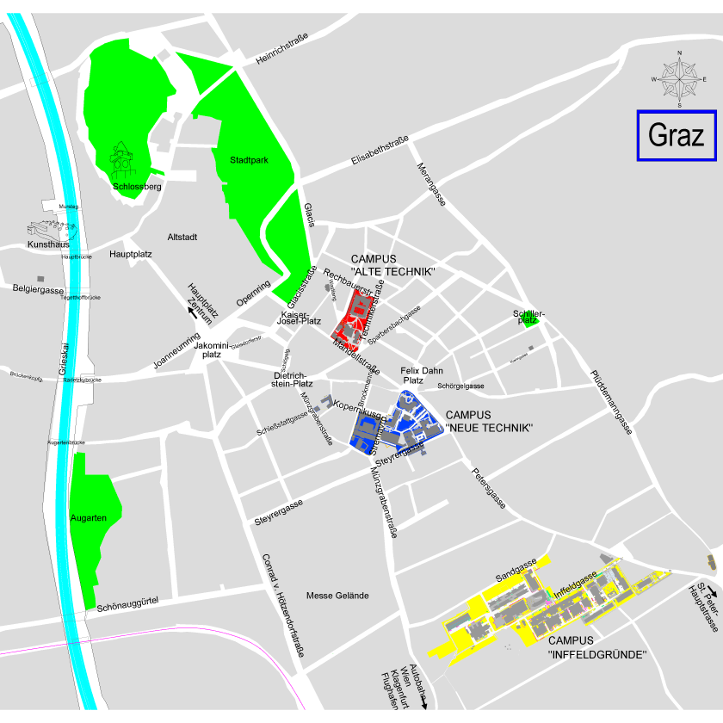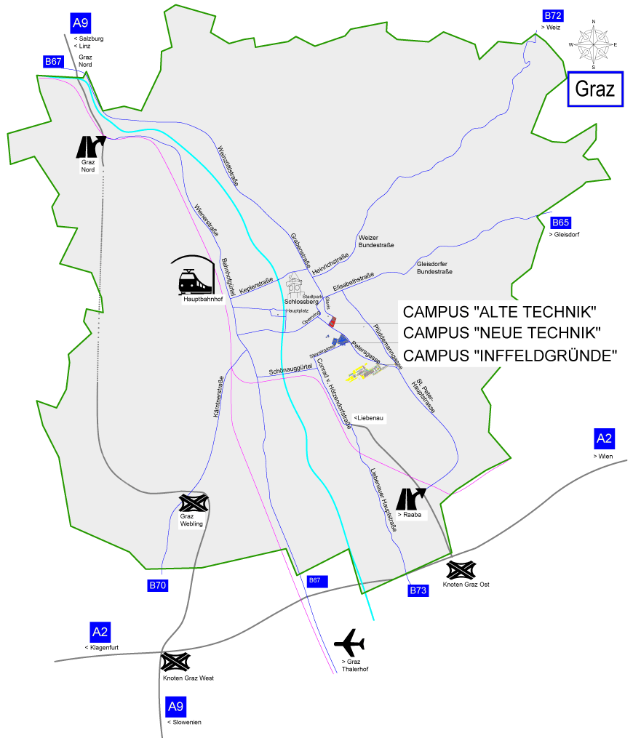

About Graz
Graz is Austria’s second biggest city after Vienna with a population of about 280.000. Graz enjoys a rich history, yet is at the same time bursting with modern life. It would not be an exaggeration to describe Graz as a city of opposites: its magnificent buildings bear witness to over 850 years of architecture in the city, such as the Landhaus, also home to the Styrian Armoury and its 30,000 weapons and suits of armour, the cathedral and the mausoleum, Schloss Eggenberg and the Grazer Burg with its double-spiral staircase. These ancient edifices merge in unique harmony with state-of-the-art works by internationally renowned architects, some from the Graz School, such as for example the Kunsthaus Graz, Joanneumsviertel, MUMUTH or the greenhouses in the Botanical Gardens.
Six universities, the biggest medieval historic city centre in Europe (a UNESCO World Heritage site), a lively cabaret and comedy scene, outstanding restaurants and bars, casino, the Grazer Messe trade fair centre and much more. See: https://www.graztourismus.at/en/good-to-know/about-graz

Program
The COST MCM and Technical Meetings will be held on Sept. 13 and Sept. 14.
On Sept. 12, a workshop will be organized by the COST IRACON EWGs Internet of Things (IoT) and Localization and Tracing (LT), the workshop on “Dependable Wireless Communications and Localization for the IoT”.
More information on the workshop and the CFP can be found here:
http://www.iracon.org/workshops/dependable-wireless-communications-and-localization-for-the-iot/
On Sept. 11, the TU-Graz Lead Project “Dependable Internet of Things in Adverse Environments” will hold its annual symposium; see http://www.tugraz.at/projekte/dependablethings

Preliminary Schedule

Registration
The contribution to the local expenses is not yet fixed but it will not exceed EUR 160,-- for all three meeting days, i.e. the workshop on Sept. 12 and the COST MCM on Sept. 13 and 14. It will cover coffee breaks, lunches, and dinner on Sept. 13. Accompanying persons may attend dinner, upon seating availability, by paying EUR 70,--. Registration deadline is Aug. 21.
Workshop-only and symposium registrations are expected to be offered free of charge, thanks to support by the Lead Project “Dependable Internet of Things in Adverse Environments”. Further details will be provided soon.

Social Events
A dinner will be offered to the registered attendees of the COST IRACON Meetings, on Sept. 13. It will be organized at the Schlossberg, which is located in the center of Graz and offers beautiful views of the City from above. (https://www.graztourismus.at/en/eat-and-drink/restaurant-guide/restaurant-guide-search/schlossberg_ga-702)
However, this means that we will have to climb the hill first, which can be accomplished in several ways:
The Schlossbergbahn funicular takes you up the castle hill of Graz in just a few minutes. It runs up Schlossberg hill every ¼ hour; more frequently if necessary. You can get to the base station via tram services 4 and 5 ("Schlossbergbahn" stop). A one-way trip on the Schlossberg costs € 2.20 for adults.
A faster way of getting up the Schlossberg is a ride on the Schlossberglift. After barely a minute it reaches the landmark of Graz, the clock tower with a fantastic view of the city and on towards the south of Styria. From there you have to continue further uphill (about 10 mins. walk) to reach the restaurant. The entrance from Schlossbergplatz square is shared by the lift, the Graz Fairytale Train and the ‘Dom im Berg’, a very special kind of event venue. A ride on the Schlossberglift costs € 1.40 for adults. Graz Linien public transport tickets are not valid here. Tram services 4 and 5 bring you directly to Schlossbergplatz square ("Schlossbergplatz / Murinsel" stop).
Or you walk directly all the way up: You climb Schlossberg hill via the 260 steps set in the rocks starting from Schlossbergplatz square or using paths from Karmeliterplatz square or Wickenburggasse street. I estimate it will take 20’ to walk up there. No special shoes required. For further information, see:
https://www.graztourismus.at/en/see-and-do/sightseeing/sights/schlossberg_sh-1251
Route information can be obtained here:
https://www.google.com/maps/dir/Current+Location/47.0765138,15.4366821
On Sept. 12, we are trying to organize a city tour but this has yet to be confirmed.

