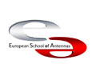
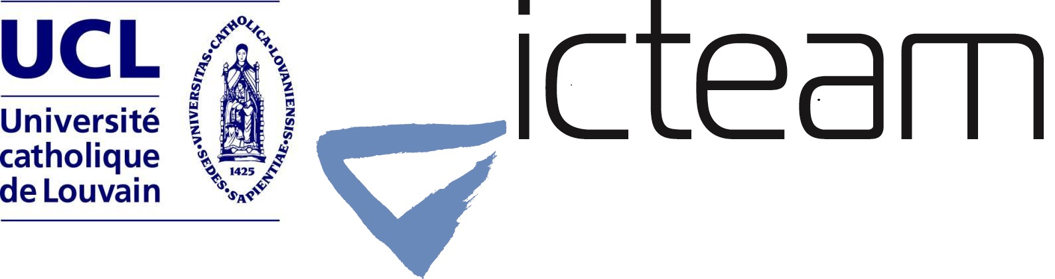

ESoA-IRACON COURSE ON
LARGE-SCALE RADIO PROPAGATION

REGISTRATION & PAYMENT FORM
Please send an electronic copy of this filled form to:
marie-christine.vandingenen@uclouvain.be AND claude.oestges@uclouvain.be

Personal Information:
Name (first / last)
Address
Postal code |  | E-mail
City |  | Fax
Country |  | Tel.

Institution/Company:
Name
Address
Postal code |  | E-mail
City |  | Fax
Country |  | Tel.
VAT number (if applicable)

Registration Fees, VAT included: (please tick the appropriate line)
 | Ph.D. Student or University Employee | € 440,00
 | Industry or Profit Institutions Employee | € 880,00

The fee includes tuition, course material, coffee breaks and a social event.

Payment:
(it can be done by cash or by bank transfer - please tick the preferred payment method)
 | Bank Transfer Payment (to be performed by June 1st, 2017)
Account name |  | Université catholique de Louvain
Bank name |  | ING rue des Wallons 2, 1348 Louvain-la-Neuve, BELGIUM
IBAN code |  | BE11.3100.9590.0148
BIC/SWIFT code |  | BBRUBEBB
Object |  | L1.31404.015 – Name Surname – EsoA Course
Very important: please do not forget the FULL communication in the bank transfer.
After the bank transfer, please send an electronic-scanned copy of the receipt to: marie-christine.vandingenen@uclouvain.be

Comments:

Date Signature

